Create a VPN profile

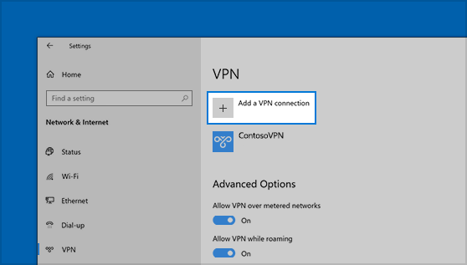

Before you can connect to a VPN, you must have a VPN profile on your PC. You can either create a VPN profile on your own or set up a work account to get a VPN profile from your company.

Before you start:

* Server is “vpn.paloaltou.edu”
* VPN type is “L2TP/IPsec with pre-shared key”
* Pre-shared key is “pauvpn”
* Type of sign-in info is “User name and password”
* User name format is “pgsp\username”

Select the **Start** button, then select **Settings** > **Network & Internet**  > **VPN** > **Add a VPN connection**.

1. In **Add a VPN connection**, do the following:
   * For **VPN provider**, choose **Windows (built-in)**.
   * In the **Connection name** box, enter a name you'll recognize (for example, PaloAltoVPN). This is the VPN connection name you'll look for when connecting.
   * In the **Server name or address**box, enter “vpn.paloaltou.edu”
   * For **VPN type**, choose “L2TP/IPsec with pre-shared key”
   * For **Type of sign-in info**, choose “username and password”
2. Select **Save**.

### More VPN Properties

1. In the More VPN Properties area, click “Edit”.

In the Security Tab, make sure “Allow these protocols” is selected and the following are checked:

* Unencrypted password (PAP)
* Challenge Handshake Authentication Protocol (CHAP)
* Microsoft CHAP Version 2 (MS-CHAP v2)

Connect to a VPN

When you have a VPN profile, you’re ready to connect.

1. Search for “VPN Settings”
2. Select the VPN connection you want to use, then press the Connect button.
3. If you're prompted, enter your username and password or other sign-in info. Make sure it begins with “pgsp\” and looks like “pgsp\username”

When connected, the VPN connection name will display **Connected**underneath it.